CS 148

Mallory Joy & Kylie Hearn

Assignment: Final Project

Random Task

Version <1.0>

Table Of Contents

Time Log 3

Introduction 4

Purpose 4

Definitions, acronyms, and abbreviations 4

Overall Description 4

Story Board 5

Assignment requirements 6

Specific requirements 7

|  |  |  |  |
| --- | --- | --- | --- |
| Time Log | | | |
| Estimated time to complete assignment => | | | 150 Hours |
| Date | Time Spent  (in hours) | Description | Author |
| 08/19/14 | 2.0 | First Version of Software Requirements | Robert Erickson |
| Halloween | 2.0 | Starts planning and making storyboard & ER diagram. Figuring out all the hopes and dreams that we have for Random Task. | Kylie & Mallory |
| Nov 1 | 2.0 | Started working on a calendar for tasks. And fiddling with some basic styles. Filling out parts of the spec sheet, creating the schema. And working on SQL statements | Kylie |
| Nov 2 | .5 | Creating a Git Repository | Kylie |
| Nov 6 | 2 | Beginning to build the register form | K |
| Nov 7 | .5 | Updating specs doc and adding to it | K |
| Nov 8 | 3 | Got register working, not confirm, fiddling with login, I hate login. Login is hard | K |
| Nov 11 | 1.5 | Worked on create task form an figured out how to make a clickable calendar text box!!! | K |
| Nov 12 | 2.0 | Did some research on implementing a proper login page. | K |
| Nov 13 | 2.0 | Some more stuff. | K |
| Nov 14 | 1.5 | Worked on fixing form and confirmation thing. | M |
| Nov 14 | 1 | Messed things up first. Redrew the storyboard. Adding content to about us. | K |
| Nov 20 | 4 | Fiddled. Idk what really, just figuring out things. Testing some stuff with data. | K |
| Nov 17 | 3 | I can’t remember. We worked together on some stuff. Did some group planning and what not. | K |
| Nov 20 | 2 | Did more crap | K |
| Nov 3 | 3 | Worked on Register, ER Diagram | Mallory |
| Nov 14 | 1 | Register | Mallory |
| Nov 21 | 1 | Login | Mallory |
| Nov 24 | 8 | Register, Confirm, Approve | Mallory |
| Nov 24 | 2 | Diddling around. Going over details. Writing up some stuff, doing research, finding problem spots and issues. | Kylie |  |  |  |  |
| Nov 24 | .5 | Conference/ discussion and stuff about project | Kylie & Mallory |  |  |  |  |
|  |  |  |  |
|  |  |  |  |
|  |  |  |  |
|  |  |  |  |
|  |  |  |  |
|  |  |  |  |
|  |  |  |  |
|  |  |  |  |
|  |  |  |  |
|  |  |  |  |
|  |  |  |  |
|  |  |  |  |
|  |  |  |  |
|  |  |  |  |
|  |  |  |  |
|  |  |  |  |
|  |  |  |  |
|  |  |  |  |
|  |  |  |  |
|  |  |  |  |
|  |  |  |  |
|  |  |  |  |
|  |  |  |  |
|  |  |  |  |
|  |  |  |  |
|  |  |  |  |
|  | Mark me wrong if not updated | <=Total Time Spent |  |

# Introduction

### Purpose

The purpose of this document is to describe the requirement specification for the web site “Random Task”.

The intended audience for this document is people wishing to gain a better understanding of the background work and ideas behind Random Task.

*First it is the contract between you and the client. Second it is for the developer of the site. Two primary goals are:*

1. *A website that will mail you a list of your daily tasks each day. Will also have a page that allows the users to contribute to a list of fun creative tasks or “Random Tasks”, and allows users to save these “Random Tasks” to their profile page so they remember them.*
2. *Developer will have to create a main page, registration page, Profile page that inserts each users data into the simplistic design once a user logs in. (We want a calendar on the page with a paper to do list on the right side, that will fill with the users tasks when they click on a day on the calendar. Below the calendar there will be a Random Task area, where the Random tasks that a user saves will display.) A page to upload tasks and the do dates, and when tasks are saved they are added to the profile calendar. A Random Task page that all users have access to. On the random task page you can browse through Random Tasks and save ones you might want to do later, you can also contribute to the Random Task page. And of course an about us/contact page.*

### Definitions, acronyms, and abbreviations

*Sample for the client:*

HTML – Hypertext markup language – used to define your content.

PHP – Personal Home Page – language that helps to customize html.

CSS – Cascading Style Sheets – used to define the look of a web site.

W3 Validation – refers to both Html and CSS validation tool provided by the W3c.org. the html validator is located at:

<http://validator.w3.org/>

with the CSS validator located at:

<http://jigsaw.w3.org/css-validator/>

# Overall Description

Random Task a website is like a personal planner, but better. You create an account and then you can input to do tasks so you don’t forget, but instead of simply writing it down and then just having to remember to do it, Random Task will email/text you your to do list for the day.

# Story Board

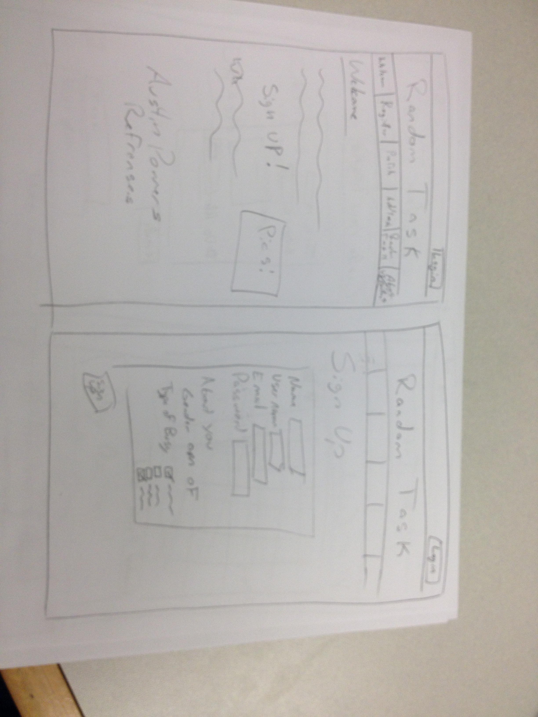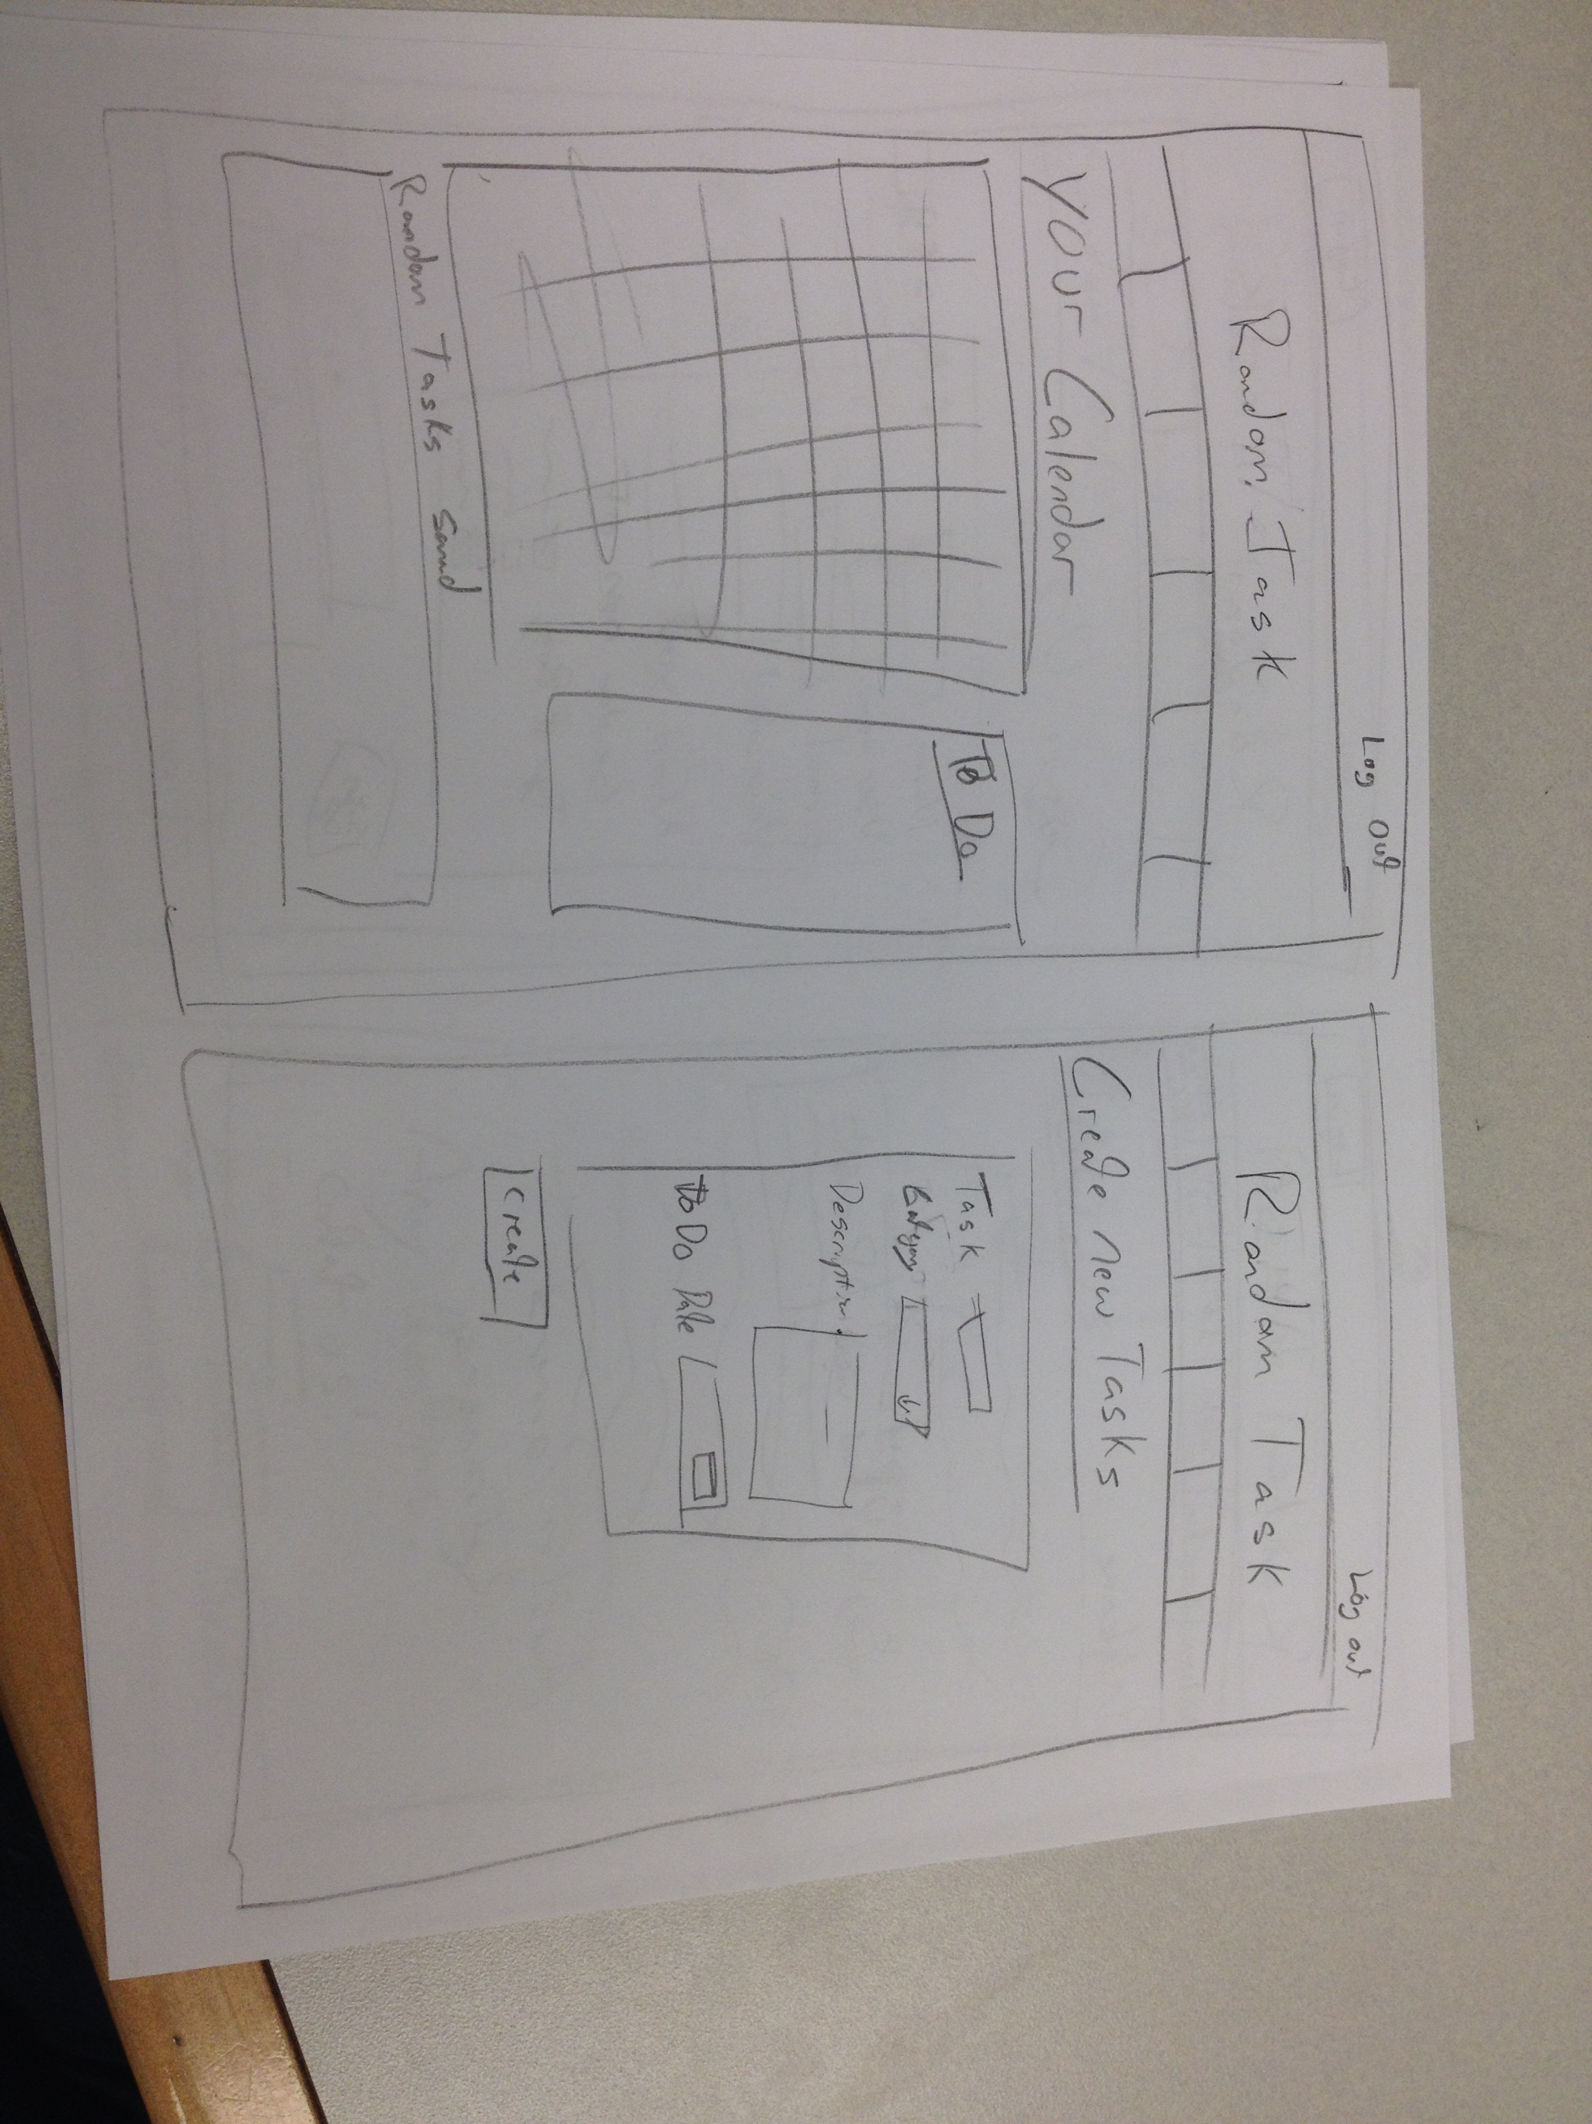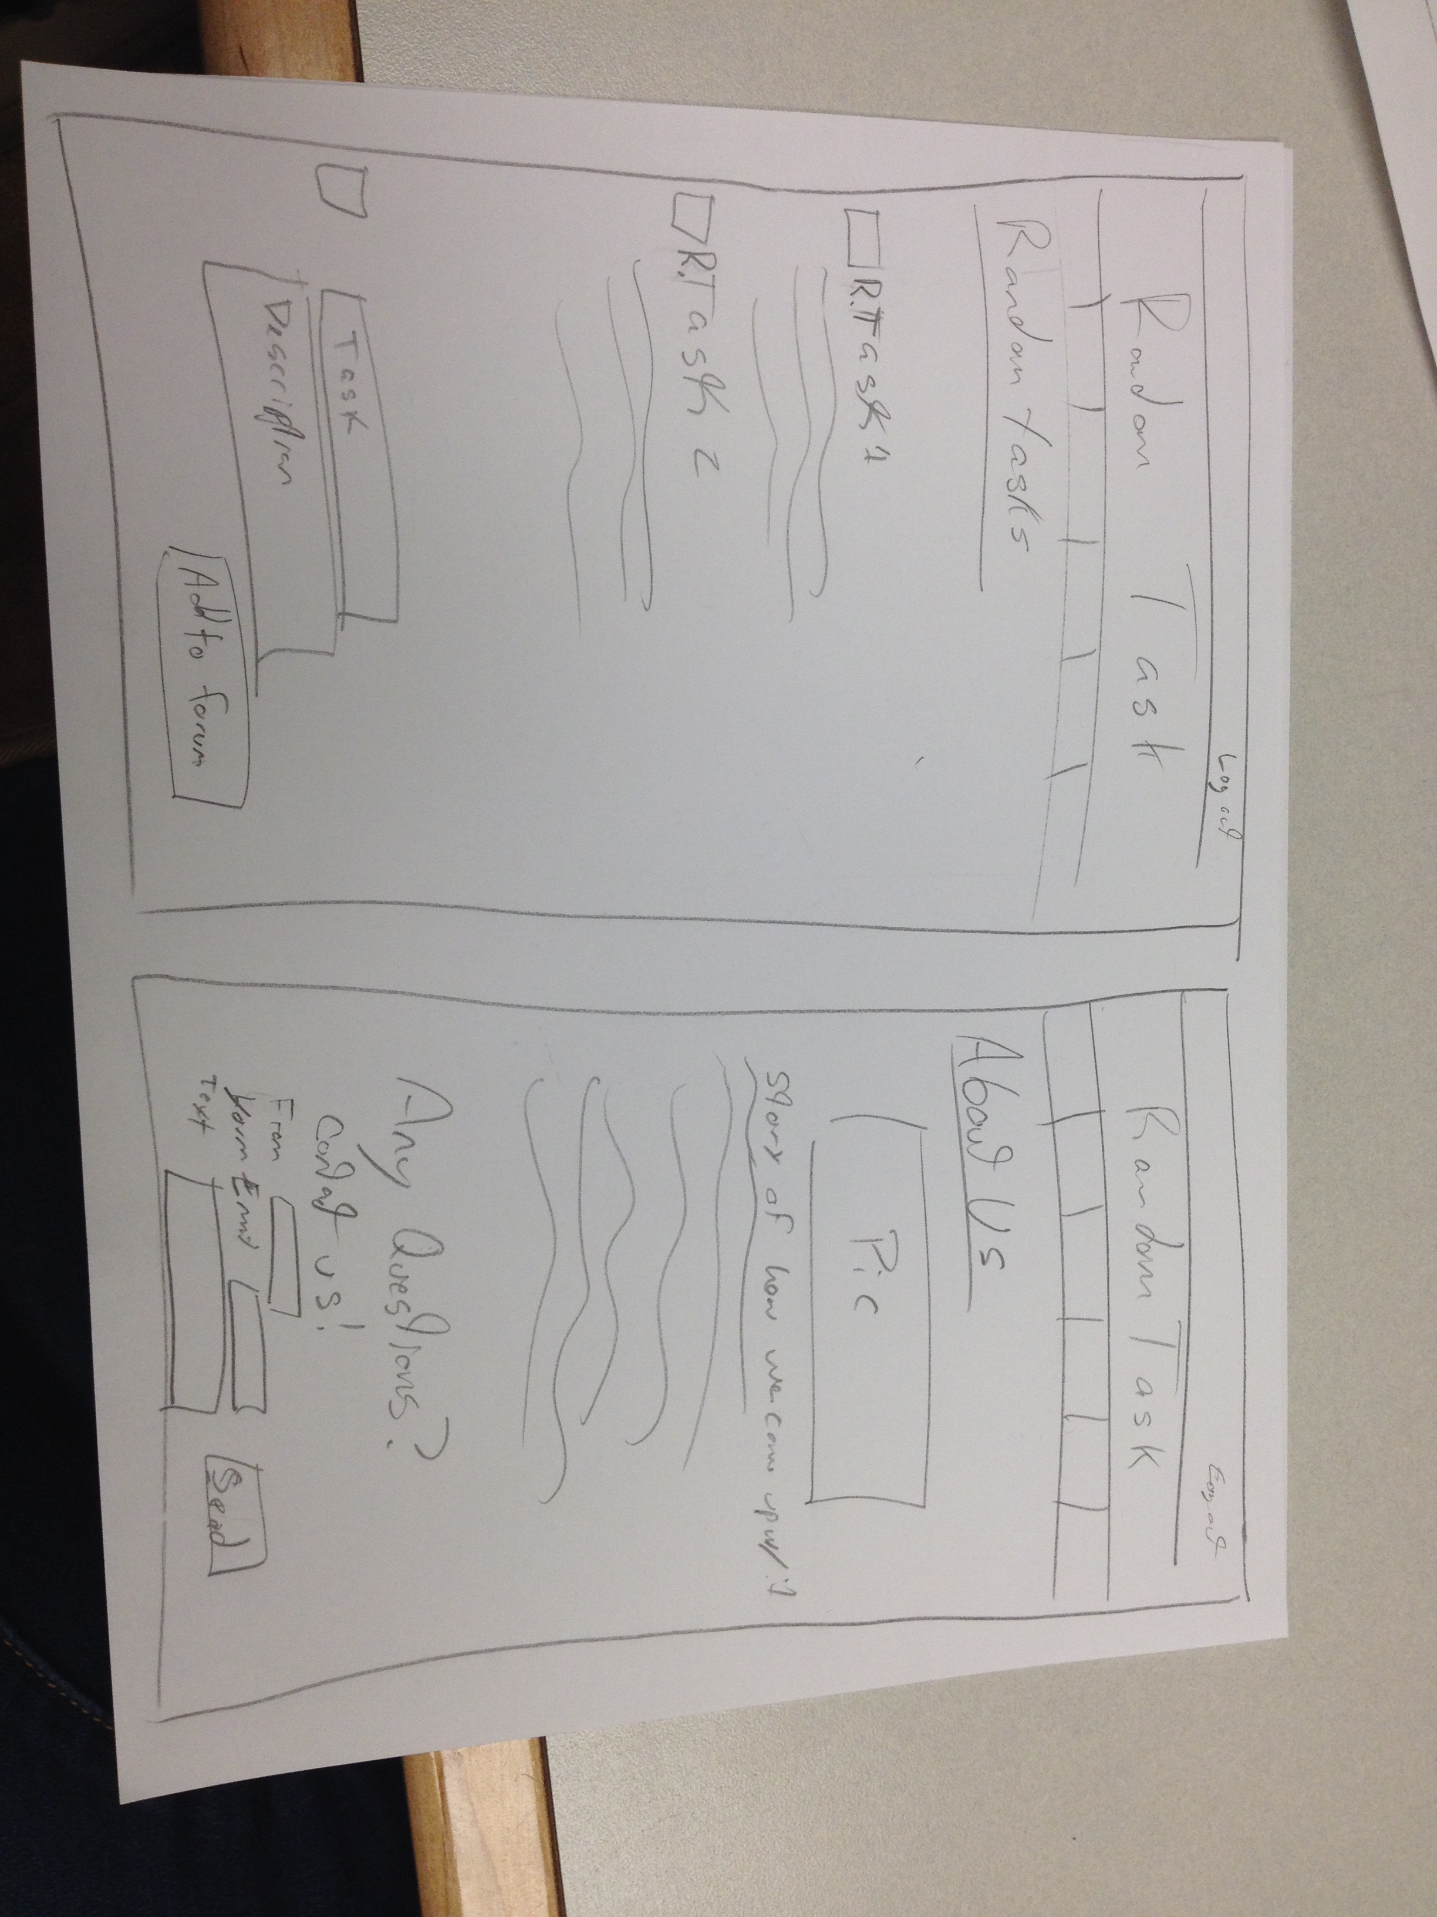

# Requirements

1. *You fill out* – This is where you would put the exact detail of what you want for the project. For example:
2. *Title for main page*:
3. *Meta Description*:
4. *Meta Character set*: UTF - 8
5. *Logo*:
6. A minimum of one form that inserts data into at least two tables.
   1. Form has one text box for a users email address, two additional text boxes, one list box, three check boxes, three radio buttons, Submit button, Field sets and legends as needed. The data should be validated for not missing, valid format etc as needed with php, appropriate error messages will be displayed. The form should email the person who filled it out and the form data should be saved to your database (one form needs to save to more than one table at once).
7. Your interface needs to allow the administrator to do the following (for all tables): Add new records (populating relation tables automatically), Update Existing records, Delete records (deleting relational records automatically), and Be sure to validate all information
8. Use git and github to version your project.
9. Have at least 6 pages
10. A database with minimum of 3 tables.

# Specific Requirements

1. Random Task is a website that reminds you of things you have to do. The idea is that you will submit a task and on the day you have to do it, we will send you either an email or a text message reminding you to do said task.
2. *Meta Character set*: UTF – 8
3. The Logo for our site is a shoe.
4. There is a Registration Form, A log in form, a Create task form, an edit/delete option, and the Random Task Forum Page form.
5. Uses git and github to version your project.
6. Database has: __ tables